LAB 8 – Building an API-powered List Screen (Flutter + REST API)
1. Objective
In this lab, students will build a simple Flutter screen that retrieves data from a public REST API, parses JSON into model classes, and displays the data using ListView.
This lab reinforces the key concepts from Module 8 – Networking & JSON, including:
- Making network requests with the http package
- Decoding JSON responses
- Converting JSON into Dart model classes
- Displaying asynchronous data using FutureBuilder
- Showing loading and error states
- (Optional) Sending data via POST requests
At the end, students will have a fully functional API-powered list screen that runs correctly in:
- DartPad (Flutter)
- Android Studio
- VS Code
2. Requirements
This lab is divided into four sub-tasks, each focusing on one major skill:
- Lab 8.1 – Simple GET Request
- Lab 8.2 – JSON → Model Conversion & ListView
- Lab 8.3 – Loading + Error Handling
- Lab 8.4 – Creating an ApiService (Service Layer Pattern)
- (Optional) POST request: Create a new item
You may complete these tasks progressively in the same project.
2.1 Functional Requirements
The final API-powered screen must:
Fetch data from a public REST API
- Use a safe and stable endpoint (e.g. https://jsonplaceholder.typicode.com/posts)
Parse JSON properly
- Convert raw JSON list → List<Model>
- Use factory Model.fromJson(Map<String, dynamic> json)
Display API results
- Render items using ListView or ListView.builder
- Show at least 1–2 fields (e.g. title, ID)
Handle async UI states
- Loading indicator (CircularProgressIndicator)
- Friendly error messages (e.g. “Something went wrong”)
- Retry button (optional)
Optional: POST
- Simple form to send a POST request
- Display success or error
2.2 Technical Requirements
Your project must:
- Use Flutter + Dart only (no third-party network libraries)
- Use the http package for API calls
- Implement model parsing with dart:convert
- Use FutureBuilder to bind async data to the UI
- Use a separate ApiService class for networking
- Run without errors on:
  - DartPad
  - Android Studio
  - VS Code
Required Widgets & Methods:
- FutureBuilder
- ListView.builder
- CircularProgressIndicator
- json.decode()
- factory Model.fromJson()
- Exception handling
2.3 Optional Enhancements (Bonus)
Students may optionally:
- Add pull-to-refresh
- Add a detail screen when tapping an item
- Add POST request to create a new item
- Improve UI with cards, icons, or thumbnails
- Add a retry button inside the error state
These are not required but improve the final score.
3. Guided Steps
Step 1 – Project Setup
- Create a new Flutter project
(flutter create lab8_networking)
or open DartPad → New Flutter
- Replace main.dart with a minimal MaterialApp
- Verify the app runs correctly before adding logic
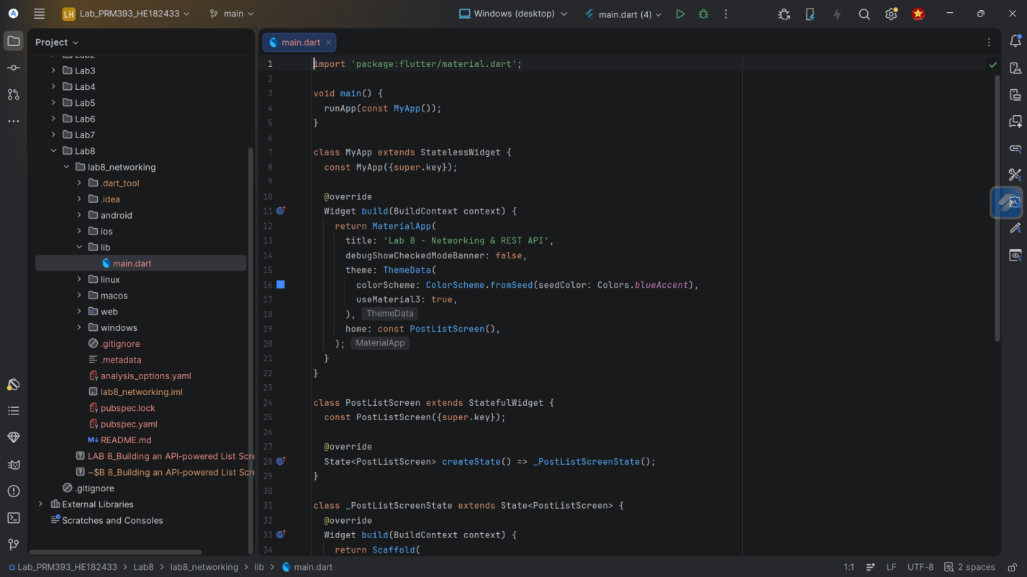
Step 2 – Call a Public API (Lab 8.1)
- Choose a sample endpoint:
https://jsonplaceholder.typicode.com/posts
- Create a function to fetch data using http.get
- Understand response format (JSON array)
- Print raw JSON for verification
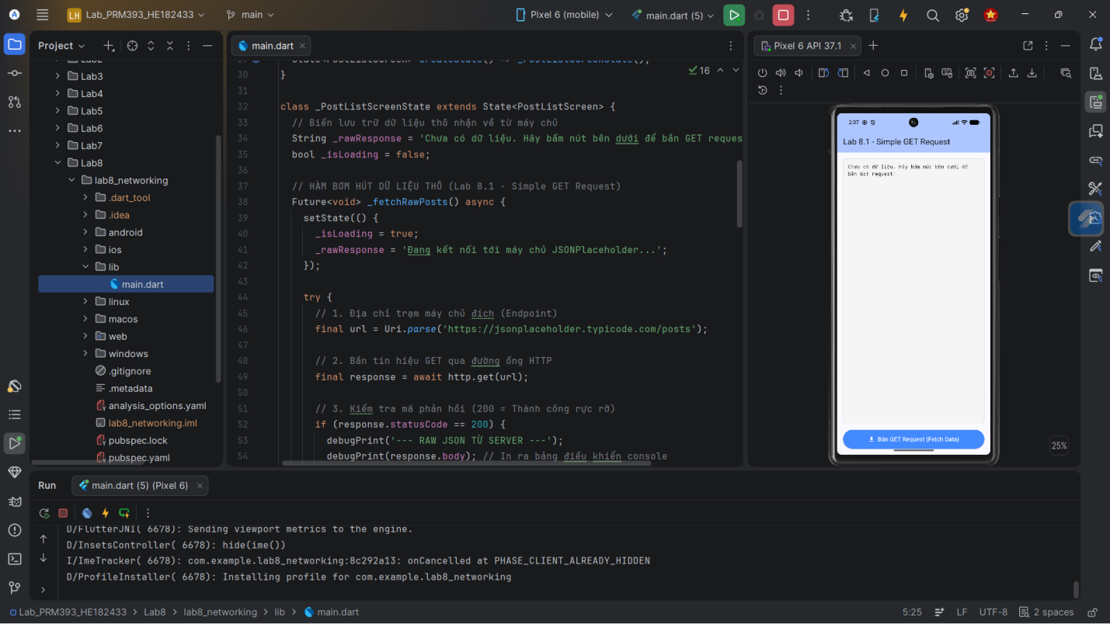
Goal: retrieve API data successfully.
Step 3 – Convert JSON → Model (Lab 8.2)
- Inspect the JSON structure and extract fields
- Create a Dart model class with:
  - fields
  - constructor
  - fromJson() factory
- Convert JSON list → List<Model>
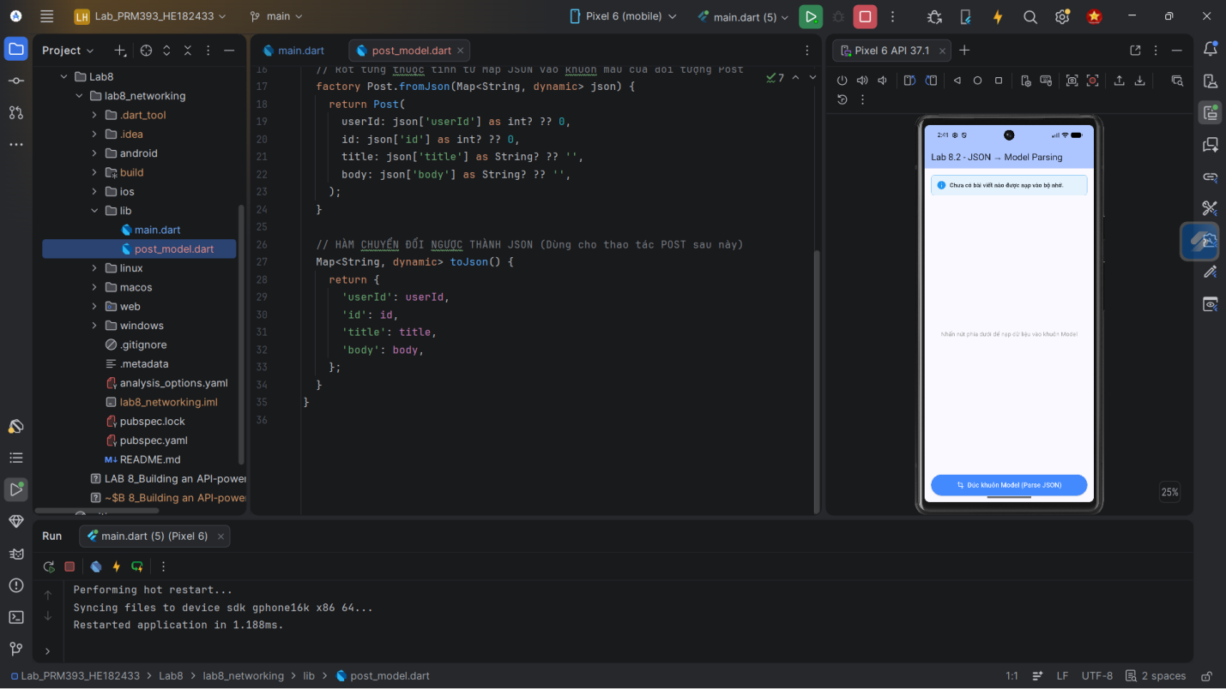
Goal: correctly parse API response into model objects.
Step 4 – Display Data Using FutureBuilder (Lab 8.2 & 8.4)
- Wrap the API call with FutureBuilder<List<Model>>
- Handle states:
  - waiting → loading indicator
  - hasError → show error
  - hasData → show ListView
- Build a clean UI with ListTile or custom widgets
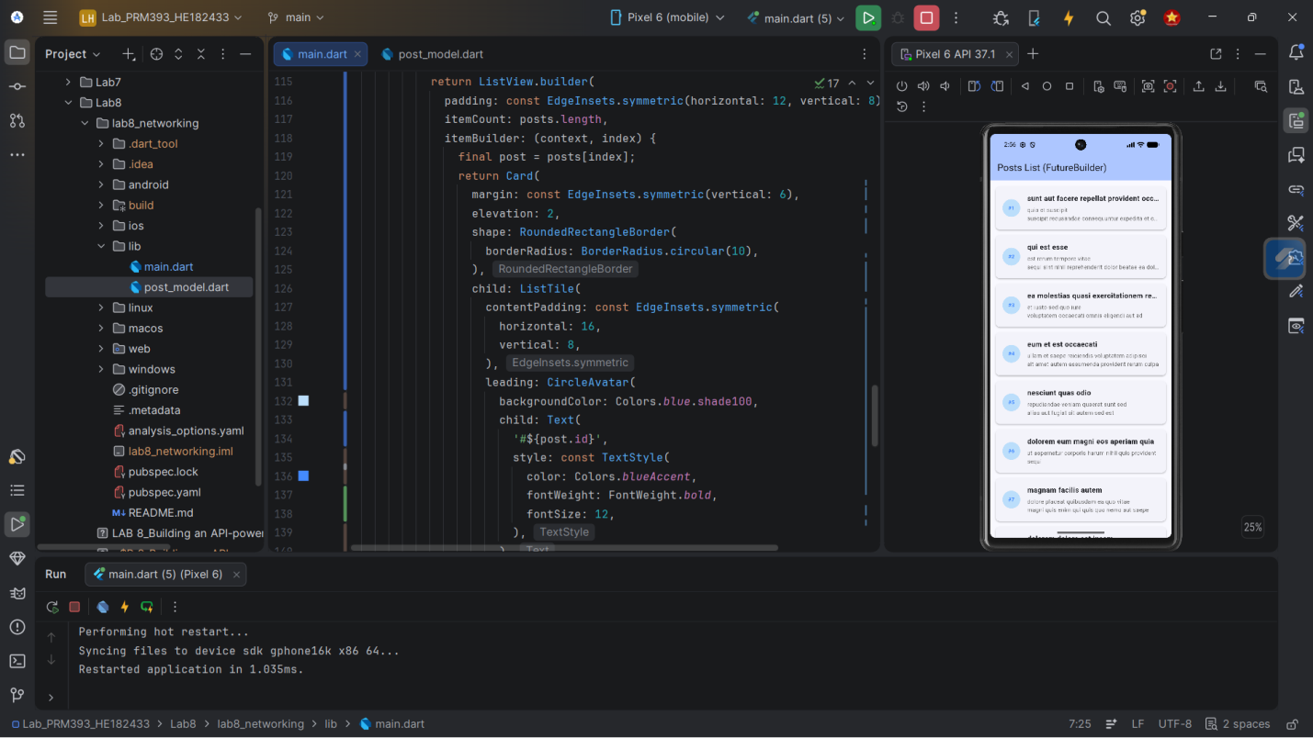
Goal: bind async API data to UI.
Step 5 – Handle Loading + Error States (Lab 8.3)
At minimum:
- Loading spinner
- Text message for errors
(Optional):
- Retry button
- Timeout handling
- Friendly fallback UI
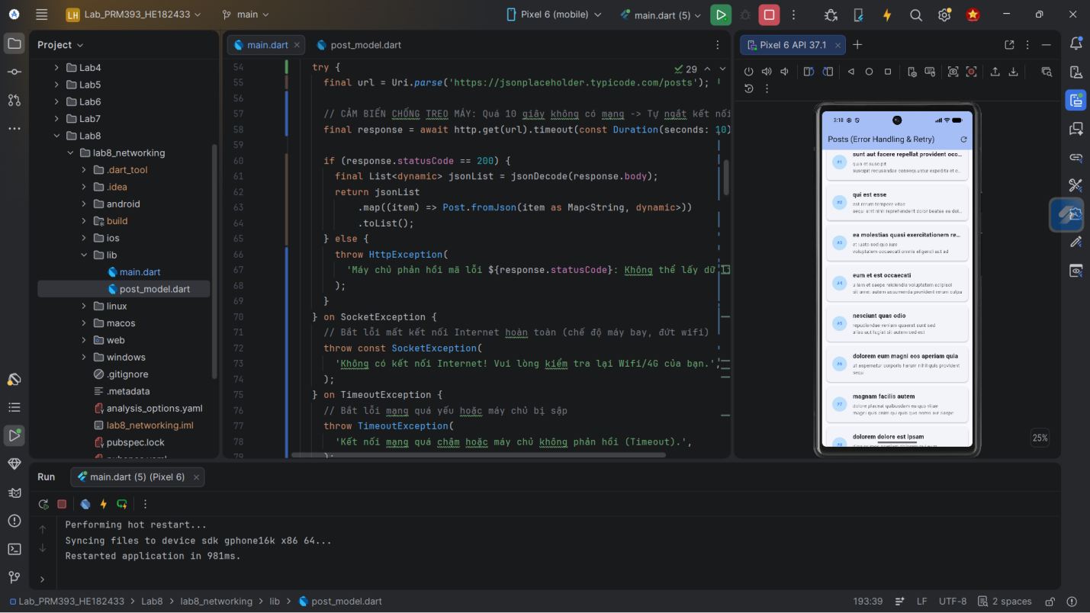
Goal: professional asynchronous UX.
Step 6 – Organize Networking Code into ApiService (Lab 8.4)
- Create a dedicated class ApiService
- Move all fetch logic into this class
- Inject http.Client for testing
- Keep UI clean and focused on rendering
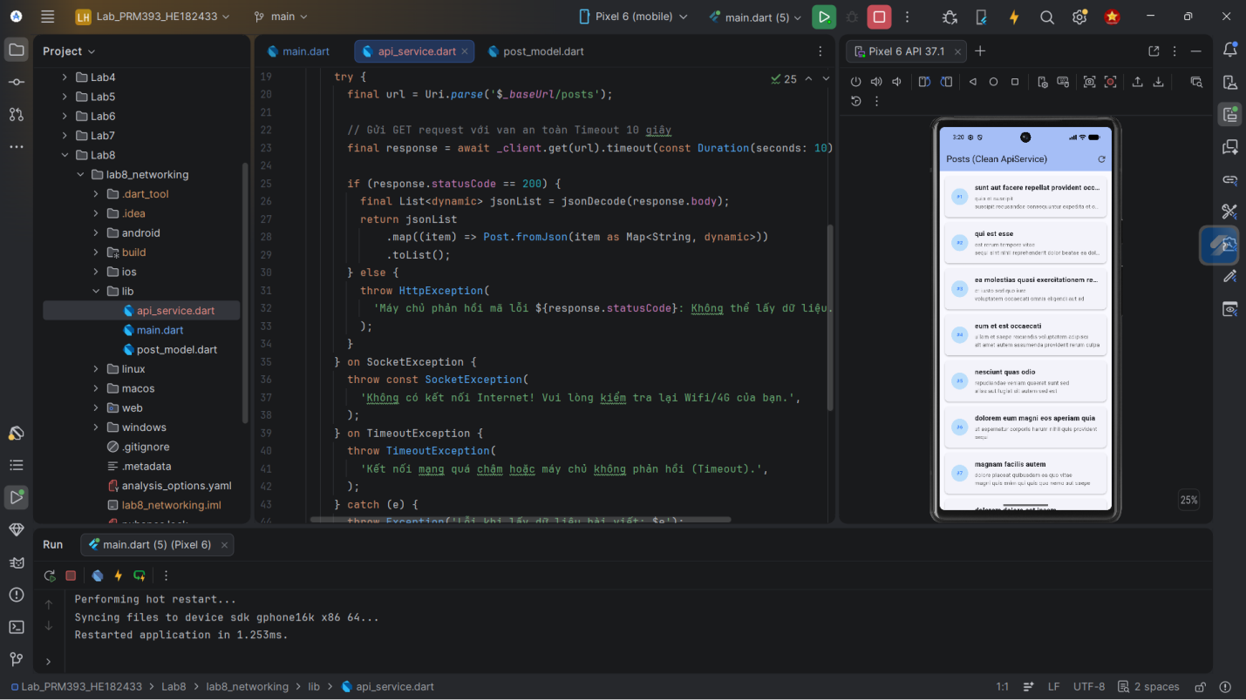
Goal: separate concerns using the Service Layer pattern.
Step 7 – Optional POST Request
- Create a simple form for a new item (title/body)
- Send POST using http.post
- Show success or error
- Update UI or print created data
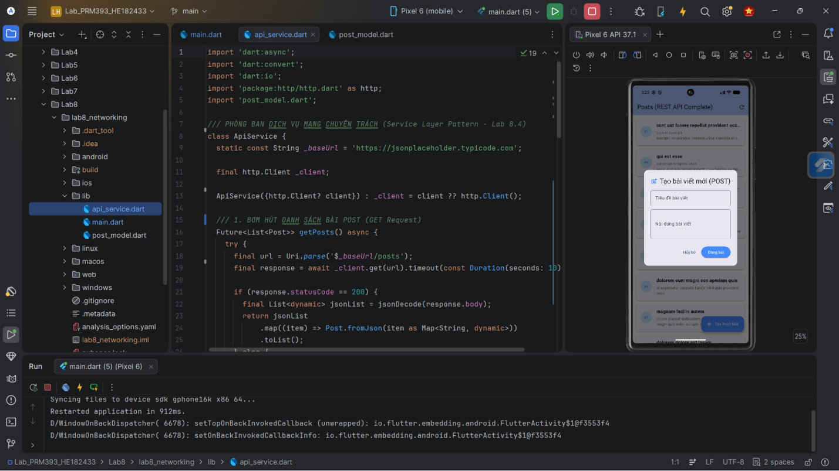
Goal: demonstrate full Read + Create workflow.
4. Expected Result
Your finished app should:
- Successfully fetch data from a REST API
- Convert JSON → Dart models
- Display the list in a scrollable widget
- Show loading state before data arrives
- Show meaningful error messages on failure
- Use a clean architecture with ApiService
- (Optional) Allow creating new items with POST
Runs in:
- DartPad
- Android Studio
- VS Code
5. Submission
Deliverables
Students must submit:
- A zipped Flutter project or
- A DartPad share link (Flutter mode)
Submission must include:
- main.dart
- ApiService class
- Model class
- Screens for list (and optional POST)
- Screenshots:
  - loading state
  - error state
  - list successfully loaded
Evaluation Criteria
Category | Weight | Description
API Integration | 30% | Correct GET request, decoding, proper use of http
JSON Parsing | 25% | Accurate model creation & mapping
Async UI Handling | 25% | FutureBuilder, loading, error states
Architecture | 10% | Clean ApiService, separation of concerns
UX Quality | 10% | Readability, clean layout, friendly error messages

